***Aim of the Experiment:***

Physical Computation of different switch interfacing with Raspberry Pi and LEDs.

***Objective:***

1. Introduction to different types of switches and explore the **concept of Pull-up and Pull- Down mode** of a switch.
2. Familiarization with push button and **reading a button** (in both Pull-up and Pull-Down mode) using Micro-Python Script.
3. Controlling an LED with button using **external Pull-Down resistors**.
4. Controlling an LED with button using **internal Pull-up and Pull-Down resistors.**
5. Implementation of a push button as **External Reset Button.**
6. Controlling an LED using a **Push Button as Toggle Switch.**
7. Controlling an LED and a buzzer using a **transistor** and a Push Button.

***Components/Equipment/items Required:***

|  |  |  |  |
| --- | --- | --- | --- |
| **Sl**  **No.** | **Name of the**  **Component/Equipment** | **Specification** | **Quantity** |
| **1** | Raspberry Pi Pico | RP2040 microcontroller  chip, 125MHz | 1 |
| **2** | Raspberry Pi Pico cable | USB Type A to Micro-B | 1 |
| **3** | Resistors (carbon type) | ¼ watt (330 Ω) | 8 |
| ¼ watt (10 kΩ) | 2 |
| **4** | LED | 3mm, Red | 8 |
| **5** | Tactile Push Button  Switches | 6 x 6 x 6 mm | 2 |
| **6** | Breadboard | 840 Tie points | 1 |
| **7** | Jumper Wire | --------------------------- | As per requirement |

***Circuit/Schematic Diagram:***

# Objective 2

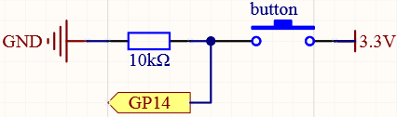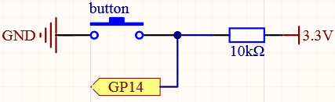

(Figure 1: Circuit diagram for implementation of reading a button in Pull Down Mode)

(Figure 2: Circuit diagram for implementation of reading a button in Pull Up Mode)

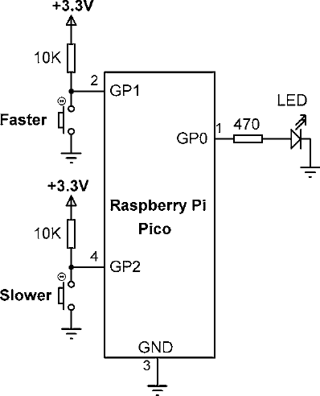

(Figure 3: Circuit diagram for controlling an LED with button using external Pull-Down resistor.)

# Objective 4

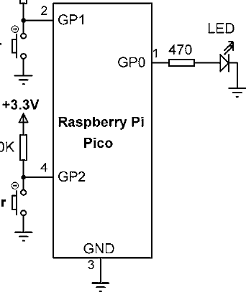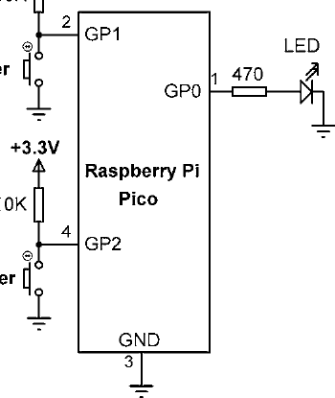

**GP16**

**GP14**

(Figure 4: Circuit diagram for controlling an LED with button using internal Pull-Down resistor.)

(Figure 5: Circuit diagram for controlling an LED with button using internal Pull-up resistor.)

# Objective 5

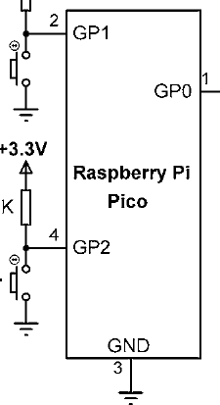

**GP38**

**GP25 (R**

**UN)**

(Figure 6: Circuit diagram for implementation of a push button as External Reset Button.)

# Objective 6

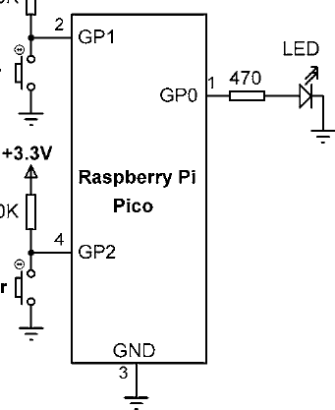

(Figure 7: Circuit diagram for controlling an LED using a Push Button as Toggle Switch.)

# Objective 7

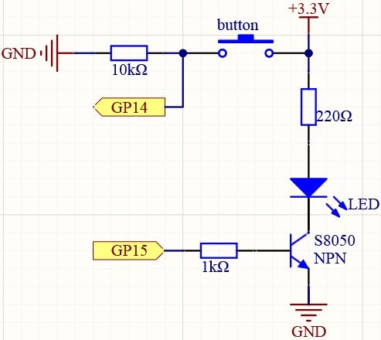

(Figure 8: Circuit diagram for controlling an LED and a buzzer using a transistor and a Push Button.)

***Observation:***

# Objective 2

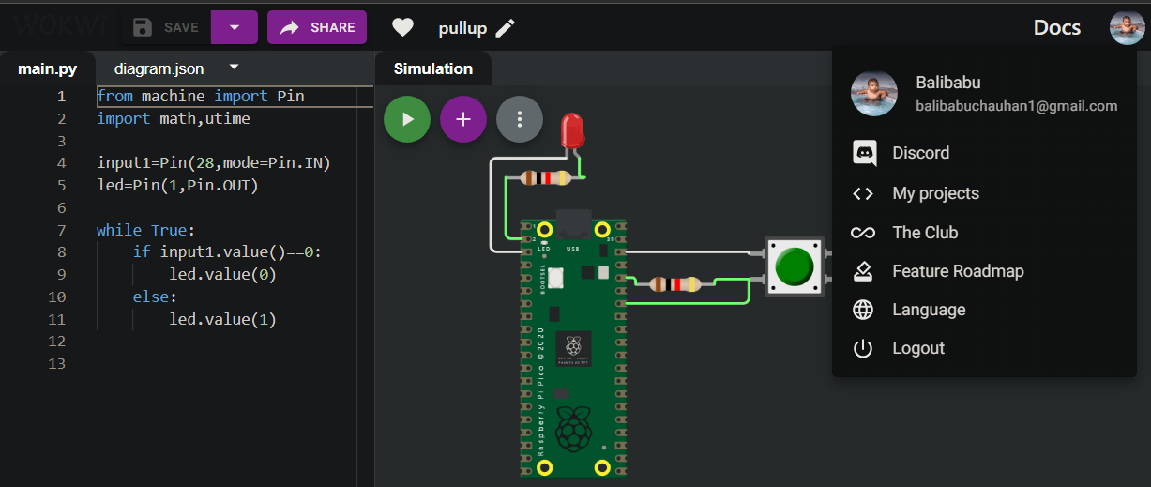

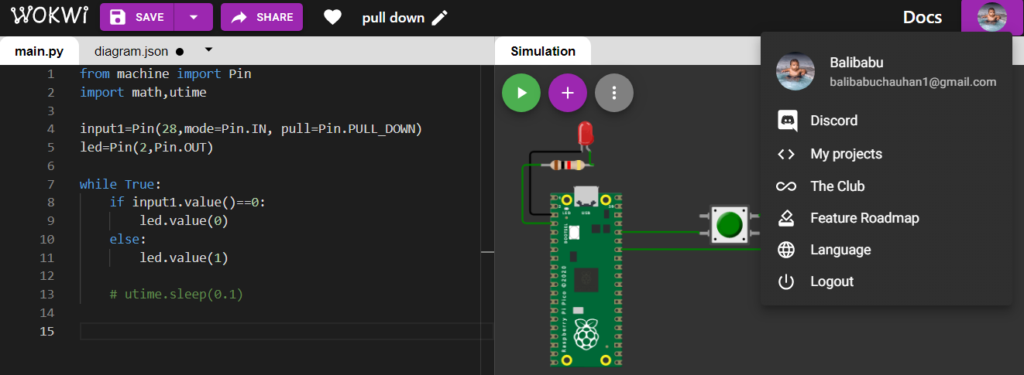

(Figure 9: Simulation based electronic circuit for implementation of reading a button in Pull Down Mode)

(Figure 10: Simulation based electronic circuit for implementation of reading a button in Pull Up Mode)

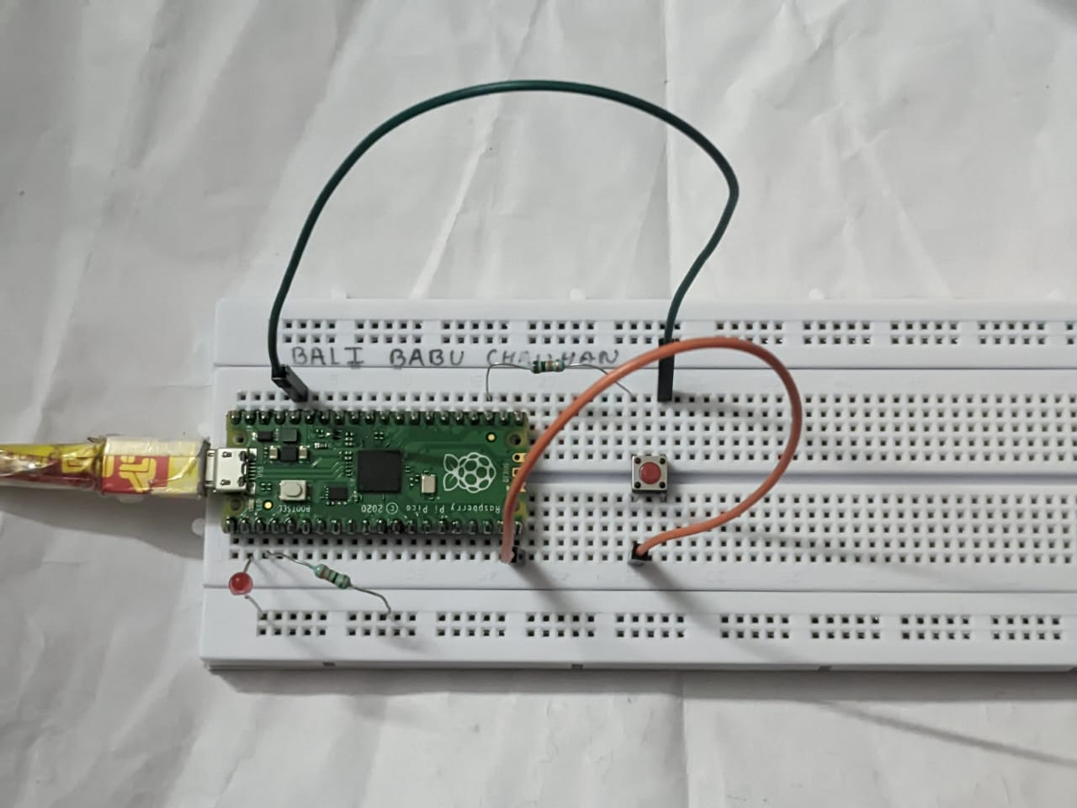

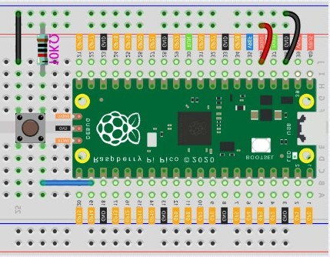

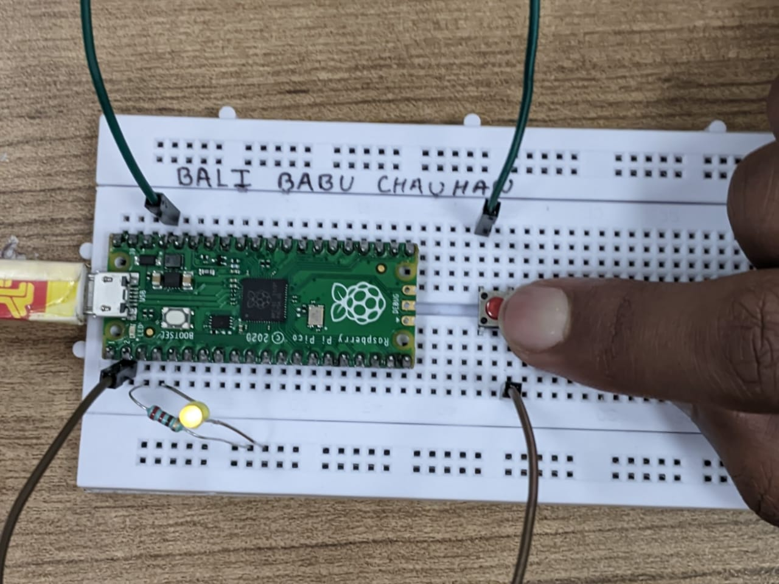

Figure 11: (Breadboard Schematic representation of an electronic circuit for implementation of reading a button in Pull Down Mode)

Figure 12: (Hardware implementation based electronic circuit for implementation of reading a button in Pull Down Mode)

# Objective 3

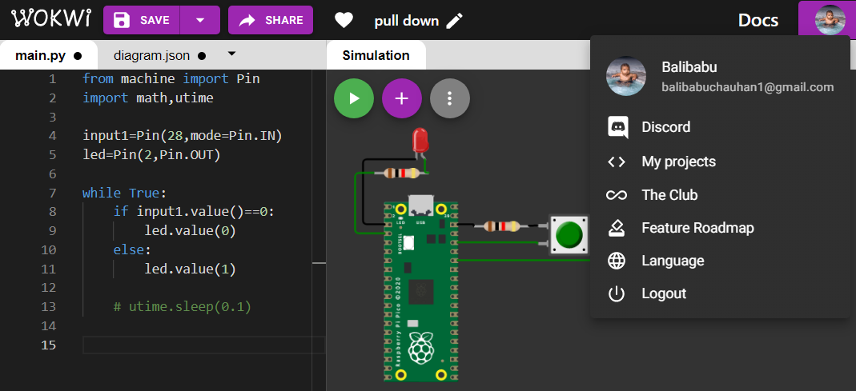

(Figure 15: Simulation based electronic circuit for controlling an LED with button using external Pull-Down resistor.)

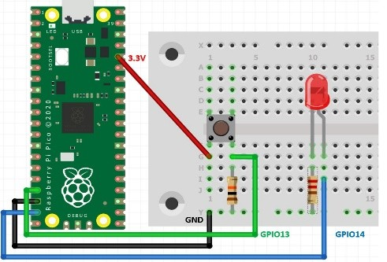

Figure 16: (Breadboard Schematic representation of an electronic circuit for controlling an LED with button using external Pull-Down resistor.)



Figure 17: (Hardware implementation based electronic circuit for controlling an LED with button using external Pull-Down resistor.)

# Objective 4

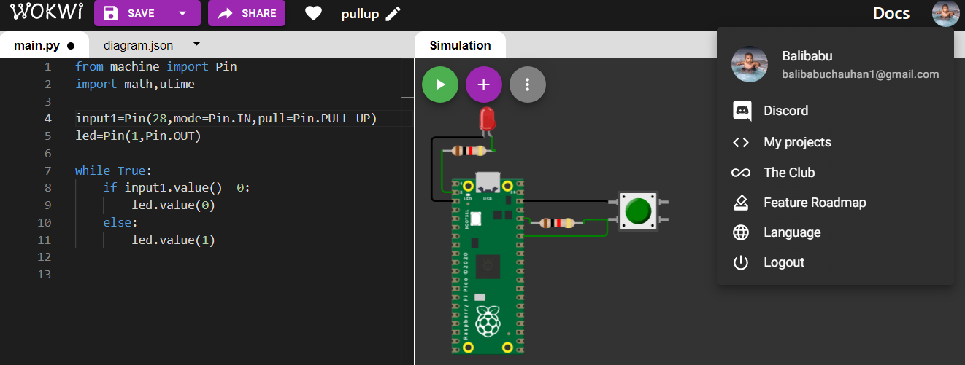

(Figure 18: Simulation based electronic circuit for controlling an LED with button using internal Pull-Down resistor)

(Figure 19: Simulation based electronic circuit for controlling an LED with button using internal Pull-Up resistor)



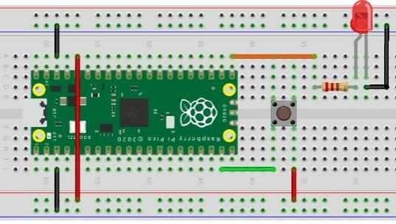

Figure 20: (Breadboard Schematic representation of an electronic circuit for controlling an LED with button using internal Pull-Down resistor.)

Figure 21: (Hardware implementation based electronic circuit for controlling an LED with button using internal Pull-Down resistor)

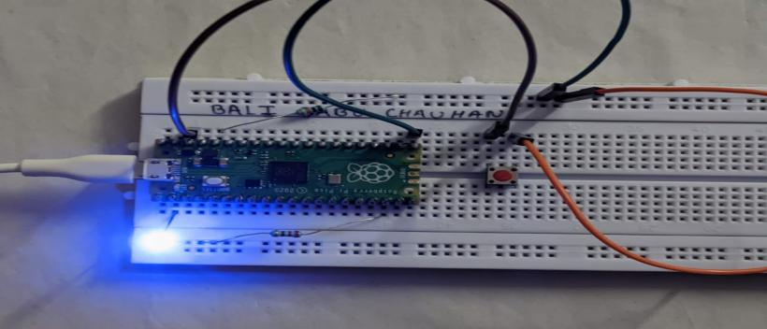

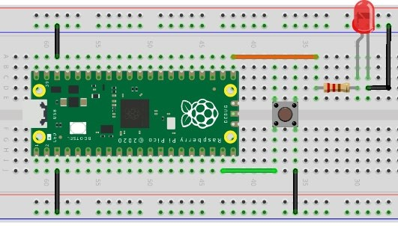

Figure 22: (Breadboard Schematic representation of an electronic circuit for controlling an LED with button using internal Pull-Up resistor.)

Figure 23: (Hardware implementation based electronic circuit for controlling an LED with button using internal Pull-Up resistor)

# Objective 5

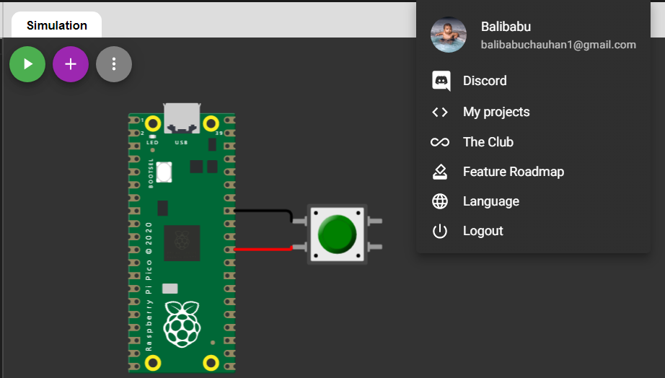

Figure 24: Simulation based electronic circuit for a push button as External Reset Button

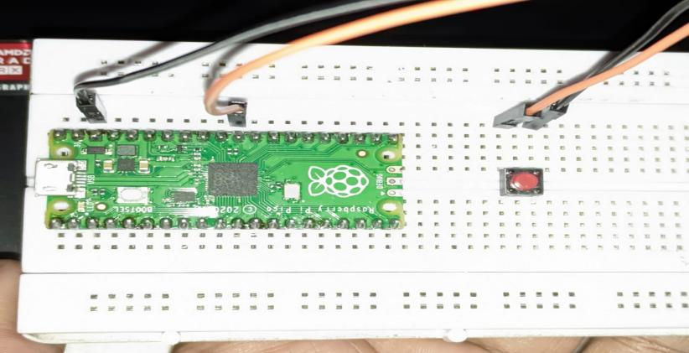

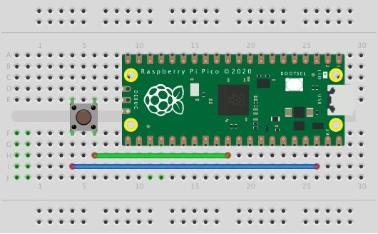

Figure 25: (Breadboard Schematic representation of an electronic circuit for a push button as External Reset Button.)

**Objective 5**

Figure 26: (Hardware implementation based electronic circuit for a push button as External Reset Button)

# Objective 6

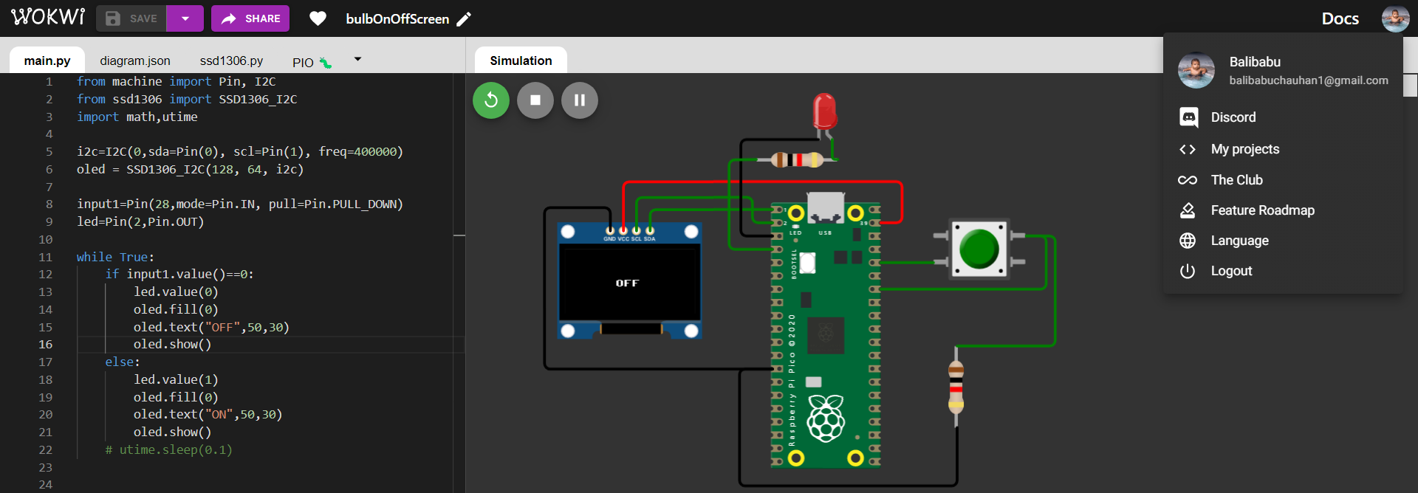

(Figure 27: Simulation based electronic circuit for a controlling an LED using a Push Button as Toggle Switch.)

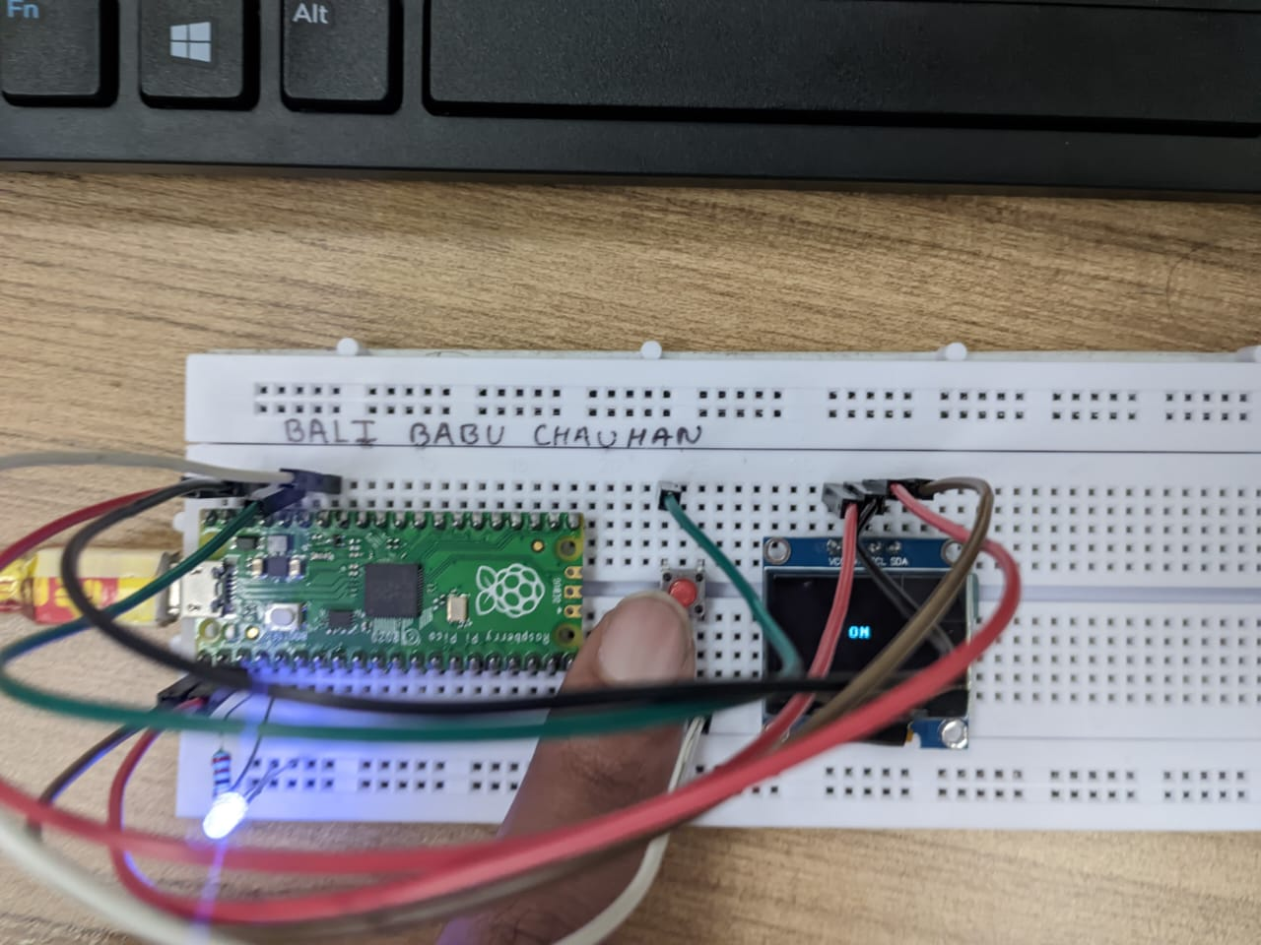

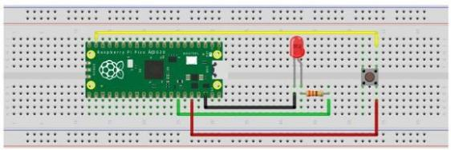

Figure 28: (Breadboard Schematic representation of an electronic circuit for controlling an LED using a Push Button as Toggle Switch.)

Figure 29: (Hardware implementation based electronic circuit for controlling an LED using a Push Button as Toggle Switch.)

# Objective 7

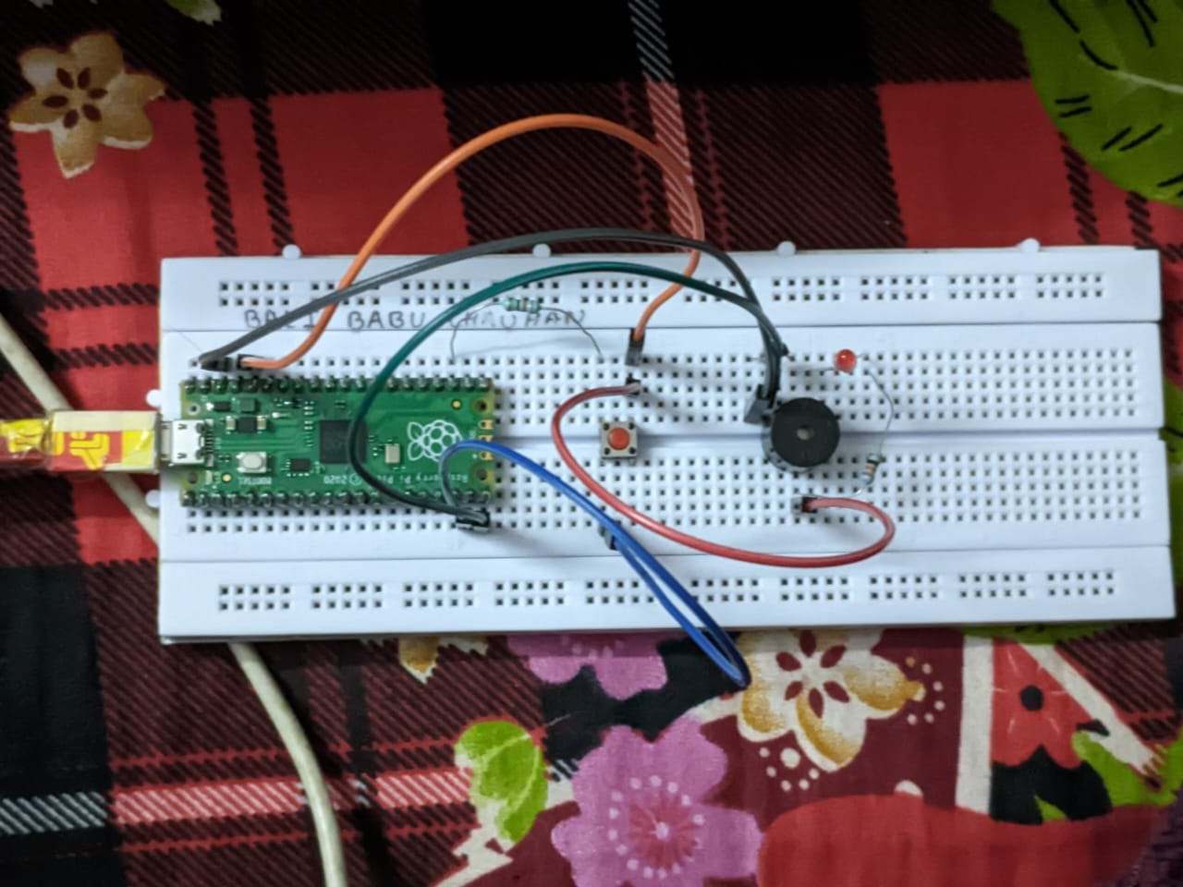

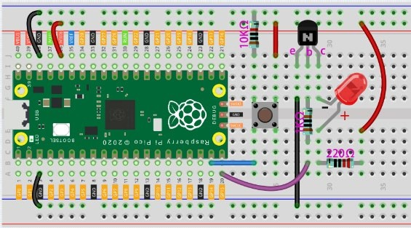

Figure 30: (Breadboard Schematic representation of an electronic circuit for controlling an LED and a buzzer using a

Figure 31: (Hardware implementation based electronic circuit for controlling an LED and a buzzer using a transistor and a Push Button)

transistor and a Push Button)

***Codes:***

# Objective 2

print("Hello, Pi Pico!")

print("This is Experiment - 4 and Objective - 2")

print("Name:Bali Babu Chauhan ; Registration No.:19410121182") print("Objective : 2 Reading a button (in both Pull-up and Pull-Down mode) using MicroPython Script.")

from machine import Pin

input1=Pin(28,mode=Pin.IN, pull=Pin.PULL_DOWN)

led=Pin(2,Pin.OUT)

while True:

    if input1.value()==0:

        led.value(0)

    else:

        led.value(1)

# Objective 3

from machine import Pin

input1=Pin(28,mode=Pin.IN)

led=Pin(2,Pin.OUT)

while True:

    if input1.value()==0:

        led.value(0)

    else:

        led.value(1)

# Objective 4

from machine import Pin

input1=Pin(28,mode=Pin.IN, pull=Pin.PULL_UP)

led=Pin(2,Pin.OUT)

while True:

    if input1.value()==0:

        led.value(0)

    else:

        led.value(1)

# Objective 6

from machine import Pin, I2C

from ssd1306 import SSD1306_I2C

import math,utime

i2c=I2C(0,sda=Pin(0), scl=Pin(1), freq=400000)

oled = SSD1306_I2C(128, 64, i2c)

input1=Pin(28,mode=Pin.IN, pull=Pin.PULL_DOWN)

led1=Pin(2,Pin.OUT)

led2=Pin(3,Pin.OUT)

while True:

    oled.fill(0)

    if input1.value()==0:

        led1.value(0)

        led2.value(1)

        oled.text("Bulb2 is glowing",0,30)

    else:

        led1.value(1)

        led2.value(0)

        oled.text("Bulb1 is glowing",0,30)

    oled.show()

# Objective 7

print("Hello, Pi Pico!")

print("This is Experiment - 4 and Objective - 7")

print("Name:Bali Babu Chauhan ; Registration No.:19410121182 ") print("Objective : 7 Controlling an LED and a buzzer using a transistor and a Push Button.")

from machine import Pin

import utime

input1=Pin(1,mode=Pin.IN, pull=Pin.PULL_DOWN)

led=Pin(2,Pin.OUT)

while True:

    if input1.value()==0:

        led.value(0)

    else:

        led.value(1)

***Conclusion:***